Use case example

XLAB Sentinel

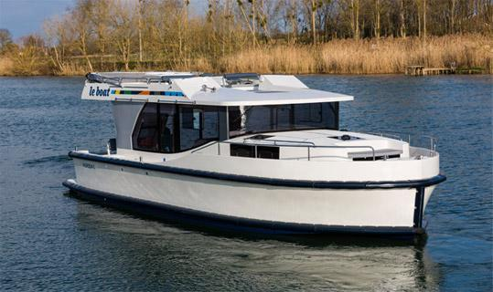We have these boats (most popular boat names)

* Serenity
* Kingfisher
* Merlin
* Osprey
* Heron
* Sandpiper
* Harmony
* 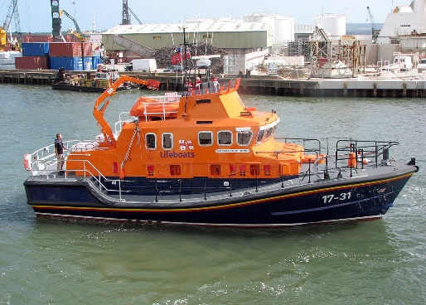Dreamcatcher
* Mallard
* Grace

And on each boat we have the sensors:

* GPS Coordinates [Supplied by Pi]
* Battery [Supplied by Arduino1]
* Bilge [Supplied by Arduino2]
* Door sensor [Supplied by Arduino3]

We would like to be able to create a journey log to share with friends

We have these ports

* 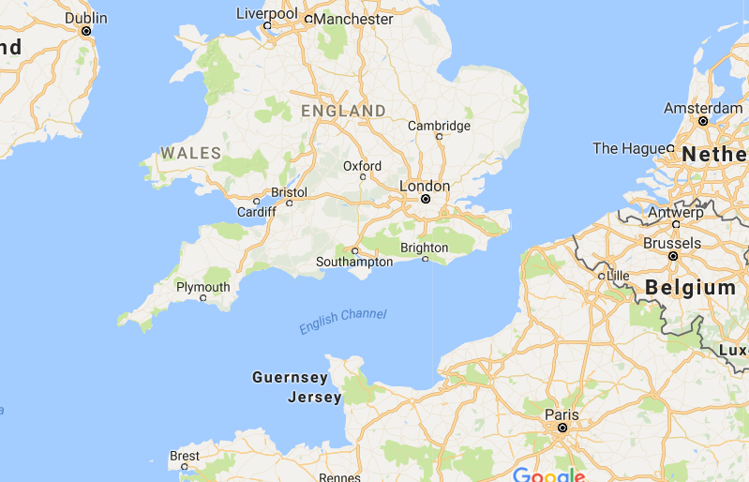UK/Dover
* UK/Hull
* UK/Liverpool
* UK/Poole
* UK/Portsmouth
* France/Le_Havre
* France/Cherbourg
* France/Dunkirk
* France/Calais
* The_Netherlands/Rotterdam
* Ireland/Dublin

Topics that each boat publishes:

* boatname/GPS
* boatname/battery
* boatname/bilge
* boatname/door

Topics that each boat subscribes to:

* country/port/storm_warnings
* country/port/moorings_available
* country/port/total_capacity

Boat’s owner would like:

* To be able to log onto website and see boat data

Arduinos:

Are local! They only ever send data up.

Use case 2:

We have these rooms:

* Coffee_room_floor_1
* Coffee_room_floor_2

And these sensors:

* Movement (IR)
* Microwave (vibration)

And an output diode which tells users whether the other microwave is in use

E.g. Pi in Coffee room 1:

* Publish Coffee_floor_1/Movement = 1
* Publish Coffee_floor_1/Microwave = 1
* Subscribe Coffee_floor_2/Microwave = 0

LED on if other microwave is on.